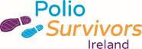

Press Release

This Season’s Must Haves for Polio Survivors Come at High Costs

Polio survivors face difficulties obtaining special footwear to maintain their mobility.

For Immediate Release – 24 October 2018

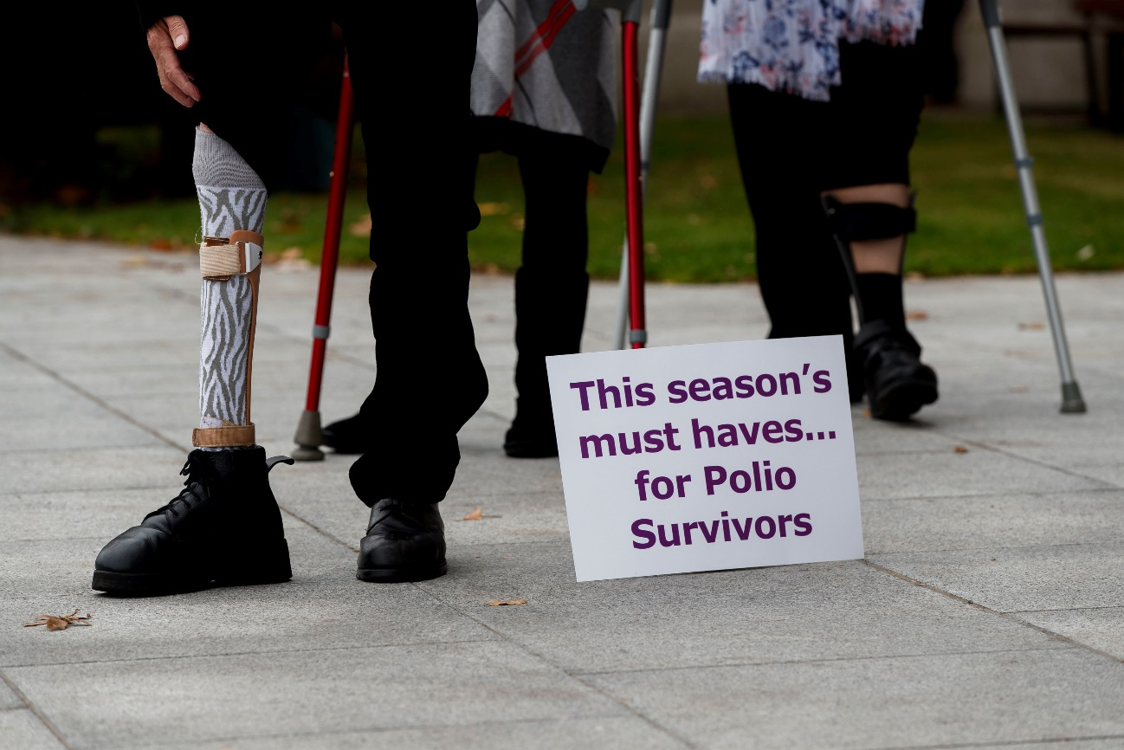

Pictured are members of Polio Survivors Ireland, a charity that provides support to people who contracted polio when babies or young children. Polio survivors have overcome enormous adversity but still need help, including customised shoes. Waiting lists for shoes can be up to 2 years or the alternative is to pay from €600 - €1,200 for special footwear essential to keep them mobile. Wednesday 24th October is World Polio Day and this year, we want to raise awareness on this season’s must haves for polio survivors - customised footwear.

“We have found that members require either different sized shoes to fit each foot or higher insteps in one to make each leg the same length,” says Fran Brennan, CEO, Polio Survivors Ireland. “On World Polio Day we are highlighting the considerable costs of this crucial footwear to polio survivors, in terms of money or, if they cannot afford it, waiting times.”

“Before I was able to receive customised shoes, I would have to go into a store and buy two separate pairs of the same shoe, one in a size 8 and the other in a size 4, just so that I could have shoes that fit each foot,” said Joe Lynch, polio survivor. “Having customised shoes specifically to fit my feet is extremely important to me as without them, I can’t get around.”

Polio survivors may also have to wait up to two years to receive customised footwear through their medical card, if indeed they have one, or incur costs of up to €1,200 – which is not affordable or acceptable.

“For one pair of shoes, I applied through my medical card and I was waiting for months and months to hear back,” said Claire White, polio survivor. “When nothing came, I reached out to Polio Survivors Ireland and they were able to fund this pair to avoid waiting even longer, which could have been up to two years.”

Polio Survivors Ireland supports those who contracted polio when babies or young children and very often these now aging individuals need help to maintain their independence and mobility. In order to be able to leave the house and to get around safely, they may need aids, such as calipers, leg braces or tailored footwear, so that falls can be avoided.

World Polio Day is marked on Wednesday 24th October 2018. World Polio Day was established by Rotary International over a decade ago to commemorate the birth of Jonas Salk, who led the first team to develop a vaccine against poliomyelitis. Polio mainly affects children under age 5. There is no cure, but it is preventable with vaccination. Polio is now only endemic in three countries and Rotary is working to eradicate polio for good.

Polio Survivors Ireland works to ensure that those who had polio, living in Ireland, can live out their lives with dignity. Late effects of polio can cause symptoms of sleep impairment, fatigue, new muscle weakness, muscle and joint pain, atrophy of muscle, cold intolerance, speech difficulties, difficulty swallowing, and respiratory dysfunction.

Ends

*further photos available

About Polio Survivors Ireland

We are the only organisation in Ireland providing practical services and support (and sometimes more importantly a listening ear) to those unfortunate enough to have contracted polio when babies or young children. We work to raise awareness of the issues faced by polio survivors and to educate medical professionals, social care providers and health policy makers about the reality for all those still impacted by the legacy of polio.

For further information contact:

Emma Clarke Conway, Development Officer, [DO@ppsg.ie](mailto:DO@ppsg.ie) or 087 2981944

Fran Brennan, CEO, [ceo@ppsg.ie](mailto:ceo@ppsg.ie) or 087 2600575

Polio Survivors Ireland, Unit 319, Capel Building, Mary’s Abbey, Dublin 7. 01 8898920. [www.polio.ie](http://www.polio.ie)