

**Strategic Plan 2017 – 2019**



**Introduction**

**About the Post Polio Support Group**

The Post Polio Support Group (PPSG) was established for Polio Survivors by Polio Survivors. The Group was formed in 1993 and is run by a voluntary Board of mostly Polio Survivors. It is supported by voluntary committees, networks of active members and volunteers and a small executive staff at the office in Dublin. Currently over 900 people are members of the organisation.

The Group assists Polio Survivors by providing stair lifts, callipers, customised footwear, electric scooters and wheelchairs. It also helps Survivors access Physiotherapy, Occupational Therapy and Respite Breaks, and helps those who need it with assistance with their heating bills each winter. The PPSG has a network of support groups around the country, provides a telephone support service for those who have difficulty in attending Group meetings and publishes a magazine “Survivor” three times a year. Any of the estimated 7,000 Polio Survivors in Ireland can contact the Group for support irrespective of whether they are a member or not.

**Foreword**

We are delighted to present our Strategic Plan for the next 3 years in the life of the Post Polio Support Group. The Board is responsible for good governance and that means that principles and procedures are in place to ensure that the organisation is run in a responsible manner. This includes having a suitable plan in place for the organisation to follow.

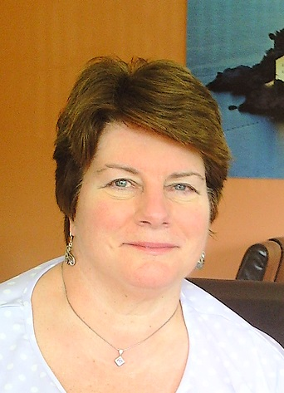

The Board takes these responsibilities very seriously and has used the creation of this plan as an opportunity to review all aspects of the organisation. We have held a number of sessions where we have considered our mission and objectives and the implications of a variety of options that are available to us within the environment in which we operate. We have consulted internally with our members and staff in order to obtain a realistic view of the needs of Polio Survivors. We have also consulted externally with other stakeholders who can bring an independent perspective to the work of the organisation.

As a result of this process, we have developed a strategic plan that we consider to be both appropriate and realistic for the future of the organisation. From this, we have identified priorities and objectives and a strategy to implement them over the next three years. We believe that this plan will sustain the organisation into the future.

I would like to thank all those who have contributed to the production of this plan. Those who have facilitated workshops, our staff, our members and others who have given of their time to ensure that the plan has been produced as a result of a comprehensive process in a culture of openness, accountability and integrity. Most especially, I would like to thank Fran Brennan, our CEO, who has encouraged and supported us through this process and who has drafted this document.



**SUSAN DOWLING**

**Chairperson**

**Where we are now**

One key issue beyond all others affects the future of the PPSG and that is that there have been hardly any cases of Polio in Ireland since the early 1960s. As a consequence the population of Polio Survivors in Ireland is gradually ageing and shrinking. This means that the overwhelming priority for the organisation is survival and sustainability. Sustainability is at the heart of every aspect of this strategic plan. Combined with this is the other major consequence of an aging population which is an increase in demand for services and supports as Polio Survivors age. The core theme of this strategic plan is to address these forces and ensure the sustainability of the PPSG and its supports for Polio Survivors over the next three years and beyond.





**Mission & Mission Goals**

The mission of the Post Polio Support Group is:

***To create awareness and to provide information regarding the late effects of polio among Polio Survivors, statutory agencies and the wider medical profession, and to ensure that the needs of Polio Survivors relating to their condition are met to enable them to live with dignity.***

The Board of the PPSG reviewed this mission statement and agreed that it still expresses thecore purpose of the Group*.*

There are three clear goals contained in the mission statement as follows:

• **Create awareness & provide information on Post Polio Syndrome (PPS) to Polio Survivors**

**• Create awareness & provide information on PPS to statutory agencies & the medical profession**

**• Meet the needs of Polio Survivors to enable them to live with dignity**

**Model**

The Post Polio Support Group is a membership organisation with members playing key roles within the organisation such as on the Board, running the social support groups and providing the telephone support service. The significant majority of members of the PPSG are Polio Survivors themselves with the remainder mostly people with a family connection to a Polio Survivor.

The Board decided that in so far as it is practicable the PPSG should encourage and sustain Polio Survivor involvement in its activities and therefore for the next three years at least the Post Polio Support Group should be:

***An organisation primarily of Polio Survivors for Polio Survivors***

This means that the PPSG wishes to continue as a membership organisation where Polio Survivors themselves are strongly represented in the membership, and Survivors play an important role in the governance and where, and as appropriate, in the operations of the organisation.

**Current PPSG Services & Supports**

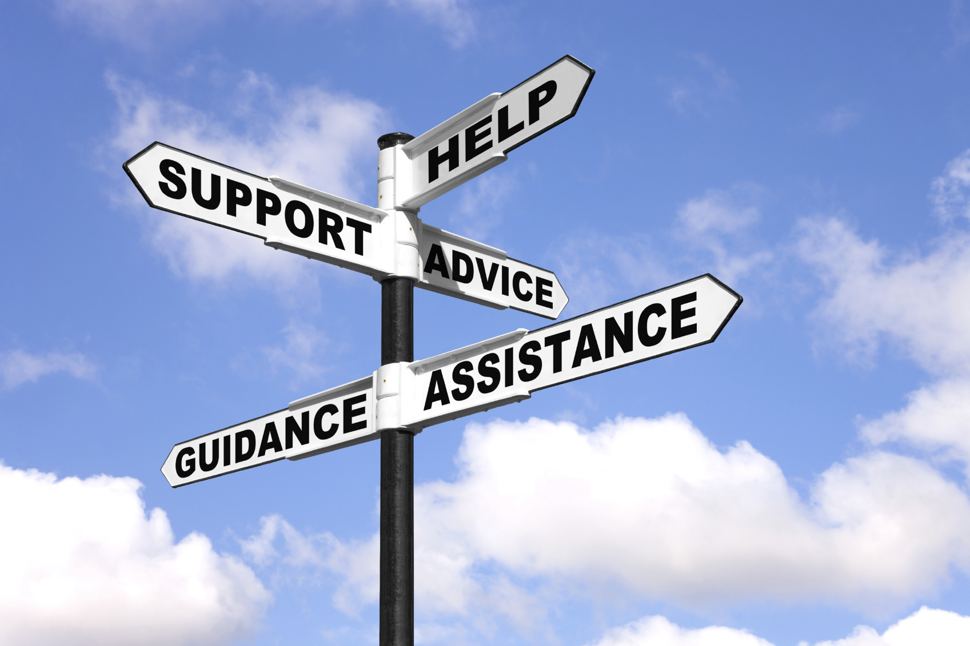

The Post Polio Support Group provides a range of services and supports to Polio Survivors including:

* Information, advice & personal advocacy
  + Aids & Appliances such as callipers, scooters, wheelchairs
* Therapies such as Physiotherapy, Occupational Therapy, Chiropody
* Respite Breaks
* Winter Heating Grant
* Stair Lifts
* Hardship Fund

In addition to these supports the PPSG also operates two other services for its members:

**Social Support Service**

There are 22 social support groups around the country in the following locations:

Athlone, Co Westmeath; Bray, Co Wicklow; Castleblayney, Co Monaghan; Carlow; Carrick on Shannon, Co Leitrim; Ennis, Co. Clare; Cork, Finglas, Swords, Clontarf and Tallaght in Dublin; Donegal; Enniscorthy, Co Wexford; Galway; Kilkenny; Limerick; Navan, Co Meath; Kildare; Castlebar, Co Mayo; Portlaoise, Co Laois; Sligo; and Kerry. Over 200 members benefit from attending regular social support group meetings and events.

**Telephone Support**

PPSG’s Telephone Support Service is a peer service provided from home to home by and for Polio Survivors across the Republic through the RingRing and PhoneChat services. These services are aimed at Polio Survivors who may have difficulties attending PPSG events or even leaving the house. RingRing is a one to one peer support service while PhoneChat is a fortnightly group conference call. At the end of 2015 there were 29 volunteers regularly calling 75 fellow polio survivors.

The Telephone Support Service is managed by a National Co-ordinator supported by three Regional RingRing Co-ordinators and a PhoneChat Co-ordinator.

**Environmental Analysis**

The environment within which the Post Polio Support Group operates has been changing rapidly in recent years. These changes have arisen as a result of the financial crisis of 2008 and accompanying recession, along with serious concerns about how some organisations in the charitable sector are run. Some of these major challenges are:



**Reduction of Core Funding:** Since 2008 PPSG’s core funding has fallen by over 25%. While the State’s finances have improved there’s no indication that this loss of funding is going to be reversed in the coming years

**Increasing Regulation:** The charity controversies of recent years has led to significantly increased regulation of charities. The main impact of greater regulation on PPSG is to increase the administrative workload on all staff reducing time available to spend on service delivery and other operations.

**Loss of Independence:** State funders such as the HSE are increasingly determining the services, supports and activities they will fund. Their priorities may not always be the same as those identified by PPSG’s members.

**Reductions in HSE Services & Supports:** Reduced HSE Disability Service budgets have led to longer waiting times for aids and appliances and therapies. This has led to increased demands from Polio Survivors for help from the PPSG.

**Cut backs in Social Welfare supports:** Reductions of social welfare benefits have also increased financial pressures on Polio Survivors and has led to more members seeking help from the organisation.

**Changes in Health Service structures:** Changes in HSE structures have highlighted issues in how PPSG is funded. Some areas, and even regions of the HSE, provide no funding to the PPSG yet we have to provide support to our members in these areas.

**Individualised Supports**: Individualised Supports involve providing funding directly to people with a disability rather than funding organisations to provide services. The person with a disability can then choose whatever supports from whichever provider they wish. While this is very positive for many people, it is likely to increase calls on PPSG for assistance in managing budgets and helping Polio Survivors choose the right services for them.

**Polio Fellowship/Rehab Group:** Two years ago the Rehab Group stopped its long-standing financial support to the PPSG and since then has only offered temporary funding.

**Difficulties Fundraising:** Trustin Irish charities has been seriously damaged trust and this has made it much harder for all charities, including the PPSG, to fundraise.

**Uncertainty:** Perhaps the greatest challenge is the high degree of uncertainty and the level of change facing all organisations in the voluntary and charitable sector which has made drawing up a strategic plan for the coming years very difficult.

**Internal Analysis**

**Strengths**

**On-going HSE Funding:** The PPSG continues to benefit from on-going funding from the HSE that meets some of the members’ needs along with general administrative and organisational costs.



**Polio Survivors and members involved in organisation:** Polio Survivors are involved in every aspect of PPSG’s operations and their self-experience of Polio ensures that PPSG is truly responsive to Survivors’ needs.

**Small, flexible organisation:** The PPSG has the ability to adapt quickly in response to changes in its environment and the needs of its members.

**Committed, experienced and skilled staff:** While small in number, the staff have a wide range of qualifications, skills and experience and through many interactions with members on a daily basis have accumulated a deep understanding of the issues affecting Polio Survivors.

**Positive culture & ethos:** As an organisation founded by Polio Survivors for Polio Survivors, the organisation is completely in tune with its target group’s needs and responds accordingly.

**Expertise within the organisation:** In addition to the staff, the PPSG also has a number of very experienced members who play an active role in the organisation.

**Weaknesses**

**Polio Survivors are ageing**: As the needs of individual members increase, the ability of many members to continue to fulfil active roles in the organisation will decline.

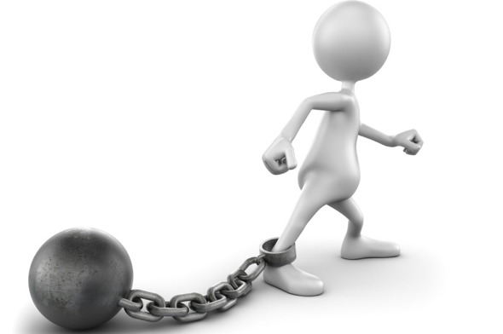

**Impact of PPS on members:** Many Polio Survivors are experiencing the effects of Post Polio Syndrome (PPS) limiting their capacity to play a more active role within the organisation.

**Fewer Active Members:** The number of active members has been falling in recent years impacting on services provided by volunteers such as the Social and Telephone Support Services.

**Low % of Polio Survivors members:** While there are no official figures, based on best estimates the proportion of Polio Survivors who are members of PPSG is between 12% and 17%.

**Membership thinly spread in many areas**: This is particularly the case in the West and North West and means it is difficult to engage in a wide range of activities in these regions.

**Not enough staff:** There is a small staff team and it struggles to meet all the increasing demands of members, funders and regulators. As the number of active members has declined in recent years there has also been increased pressure on staff to help fill gaps.

**Little Awareness Raising & Education Work:** Perhaps as a result of the falling number of active members, and staff work overload, this activity has declined in recent years.

**No Local or Regional Structures in PPSG:** In the absence of a branches or similar structures, organising activities and developing leadership skills among members is more difficult.

**Communication with members a challenge:** Low email usage, limited mobility and poor public transport combine to make communication with members a challenge.

**Limited & Restricted Funding:** PPSG’s funding comes from 8 HSE regions but the money provided bears no relation to the numbers of members in these regions. There are also significant restrictions on what this funding can be used for.

**Unsuitable Office:** The office sharing arrangement with another company and the lack of a proper meeting room, make the office unsuitable. The location is also an issue as some members have difficulties in travelling into Dublin City Centre.

**Consultation**

**Services & Supports Planning Working Group**

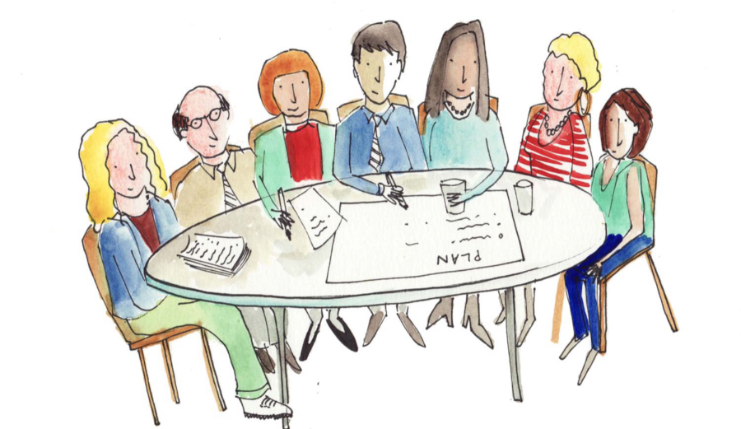

In early 2016 the Board established a working group of Board members and staffto consider what services, supports and activities the PPSG should deliver in accordance with its mission during the lifetime of the plan. The Working Group commissioned a consultation process of stakeholders to obtain a range of views.

**Member Survey**

A representative sample of 90 members based on geographic location, age category and income level were surveyed. Members were asked to identify their needs and express their views on PPSG’s current services and supports. The survey was conducted by post and ‘phone with the assistance of an external consultant to ensure complete confidentiality.

**Social Support Survey**

A shortened version of the member survey was sent to all the social support groups. The groups were asked to complete this survey collectively as a group. 14 of the groups contributed to the survey.

**Stakeholder Survey**

The Working Group identified a number of external stakeholders such as doctors, Physiotherapists and Occupational Therapists whose views were sought as part of the consultation process. 7 out of 26 stakeholders who were surveyed online completed the questionnaire.

**Staff Consultation**

Staff members met to consider the major needs of Polio Survivors based on their experience on interacting with, and helping members. Their feedback demonstrated the complexity and inter-related nature of many members’ needs.

**Report**

The Services & Supports Working Group considered the feedback arising from the consultation process and produced a summary of members’ needs below:

**Conclusions**

The Board of the PPSG considered the findings of the consultation process and the recommendations of the Services & Supports Working Group. The Board believes that the PPSG will not be able to meet the increasing need of Polio Survivors in the coming years as the chart below illustrates.

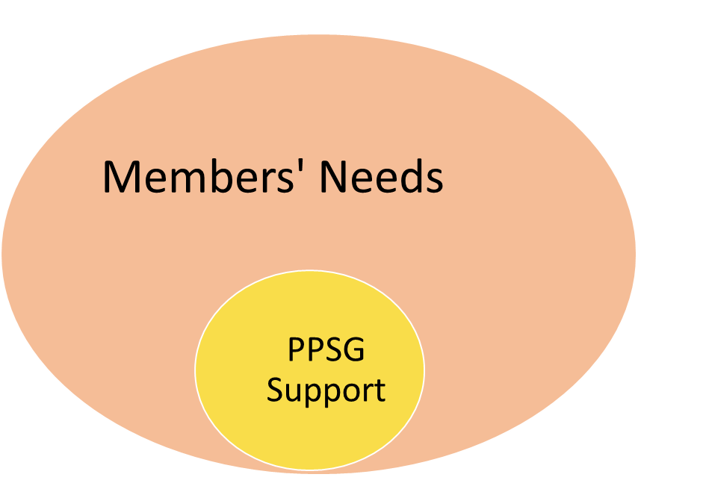

The feedback demonstrates that most members’ needs will continue to be met by State services. However these services and supports require significant improvement. Therefore this plan envisages a gradual reallocation of some resources from PPSG’s direct provision of aids, appliances and therapies towards advocacy, educational and promotional activities. These will involve reaching out to more Polio Survivors and empowering them to access the services, supports and benefits they need.

**Strategic Priorities & Expected Results**

Based on its consideration of the external environment, the organisation’s internal strengths and weaknesses, and the findings of the consultation process the PPSG’s Board has set the following key strategic priorities for the Post Polio Support Group over the duration of this plan...



**Strategic Priority 1: Directly provide a range of services and supports that assist Polio Survivors in maintaining their independence, reducing their social exclusion and enhancing their quality of life.** Expected results are:

1.1. Polio Survivors receive aids, appliances, therapies and respite breaks when they need them i.e. when these supports are not available on a timely basis from the HSE or other services

1.2. Polio Survivors on very low incomes receive assistance in meeting their heating bills each winter.

1.3. Polio Survivors can attend support group meetings near them where they can benefit from peer support, social activity and information exchange minimising their sense of social exclusion.

1.4. Polio Survivors who have difficulty in travelling to meetings, and are at risk of social isolation, have regular telephone contact with a fellow Polio Survivor where they can share experiences, learn more about Group activities or just have a friendly chat

**Strategic Priority 2: Inform, educate and assist Polio Survivors in accessing the services, supports, medical care and benefits they require.** Expected results are:

2.1. Polio Survivors know how to access services, supports and entitlements they need

2.2. Those Polio Survivors who need it are supported in securing the services, supports and benefits to which they are entitled

2.3. Members of PPSG receive regular and understandable information on the work and activities of the Group, along with services and supports that are available and other useful information

2.4. Members understand their rights and entitlements and are empowered to seek help and support from appropriate sources. Members are also aware of public policy issues affecting them and their entitlements

2.5. The wider population of Polio Survivors are more aware of Post Polio Syndrome, available services, supports and benefits, the work of PPSG and other issues relating to their Polio that may concern them

**Strategic Priority 3: To advocate for improved statutory provision of services, supports, medical care and social welfare benefits for Polio Survivors.** Expected results are:

3.1. Significant reduction of the waiting times Polio Survivors experience for aids and appliances

3.2. Readily available therapies at primary care level for Polio Survivors with medical cards

3.3. Extension of medical card eligibility to a greater number of Polio Survivors

3.4. Improved neurological services, social welfare benefits and other entitlements for Polio Survivors

**Strategic Priority 4: To develop the organisational, Board and staffing structures in PPSG to implement this plan and achieve these objectives.** Expected results are:

4.1. 75 new people appointed to roles within the organisation by 2019

4.2. Effective management & support structures in place for all active members & volunteers

4.3. Board has range of skills & experience available to it to fully discharge its governance responsibilities

4.4. Effective working Board Sub-committees overseeing key aspects of PPSG’s work and managing risk

4.5. Staffing with appropriate skills in place to implement actions & achieve objectives in this plan

4.6. Funding is available to deliver on actions within this plan

**How we will achieve these Results**



Successful implementation of this plan is dependent on three key underlying strategic approaches:

* **A focus on the recruitment of new Polio Survivor members over the duration of the plan**
* **PPSG as a Hub for Polio Survivors advising, directing and supporting Survivors in accessing the services, supports and benefits they need**
* **Benefitting from overlaps between educating Polio Survivors, recruiting new members and advocacy/campaigning activities**

**Implementation**

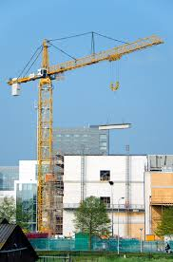

At the start of each year the Board will approve an implementation plan that outlines a range of activities and actions to be undertaken in that year to achieve the plan’s objectives. At the end of that year the Board will review progress against the targets for that year and consider any issues arising that may impact on the achievement of the strategic plan’s overall objectives before agreeing the implementation plan for the next year.