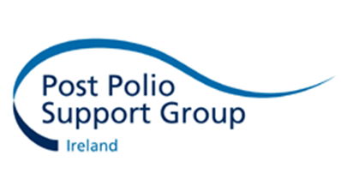
Press Release

World Polio Day
Buildings Light Blue to highlight Legacy of Polio
‘We’re Still Here’ - Survivors still impacted 60 years on

For Immediate Release – October 2016

With as many as 7,000 Polio Survivors estimated to be still living with disabilities brought on by the disease, notable buildings around Ireland are lighting up blue to mark World Polio Day on Monday 24th October, including Dublin City Hall, Cork City Hall, Christchurch Cathedral Dublin, Kilkenny Castle and An Táin at the Town Hall, Dundalk.

“Most people think polio is gone – and while thankfully the disease is on the verge of eradication, many people live daily with pain, fatigue and severe intolerance to cold. Some might even be unable to undertake even customary activities such as making a cup of tea – these are some of the problems caused by Post Polio Syndrome,” says Fran Brennan, CEO of the Post Polio Support Group. “Without the support and services we provide to ensure that members have their needs met in relation to polio, many people would suffer in silence and be isolated and perhaps in danger of falls without the aids and appliances that we help them obtain.”

The Post Polio Support Group wants the public, the media and the medical profession to be aware of their services as there are many survivors who will need their support in years to come, but who do not know that help and a listening ear is at the other end of a phone.

About the Post Polio Support Group
The Post Polio Support Group is working to raise awareness of the continuing difficulties faced by those who survived the original virus before Polio was eradicated in Ireland. Some survivors are suffering from the late effects of Polio, also known as Post Polio Syndrome, significantly increasing their disability and causing pain and fatigue later in life, as many as 20-40 years after the original virus struck.

The Post Polio Support Group was established for Polio Survivors by Polio Survivors in 1993. It is the only organisation in Ireland providing practical support (and sometimes more importantly a listening ear) to those unfortunate enough to have contracted Polio when babies or young children.

The Group provides stair lifts, calipers, bespoke footwear, electric scooters and wheelchairs. It also help Survivors access Physiotherapy, Occupational Therapy and Respite Breaks, and has a national network of support groups. At this time of the year the Group is particular focused on providing a winter heating grant to those Polio survivors who have difficulty staying warm each winter. The Group also works to raise awareness, provide information on Polio and its late effects and to ensure Polio Survivors can live with dignity.

For help and support contact: 01 889 89 20 or info@ppsg.ie www.ppsg.ie

For media information only please contact:
Emma Clarke Conway, Development Officer, DO@ppsg.ie or 087 2981944
Fran Brennan, CEO, ceo@ppsg.ie or 087 2600575
Post Polio Support Group, Unit 319, Capel Building, Mary’s Abbey, Dublin 7, 01 8898920.

